Ramble OnTM
Software Design Description

Author: Leixiang Wu
Stony Brook Student
March, 2013
Version 1.0

Abstract: This document describes the software design for Ramble On, a casual game for playing with many countries’ map.

Based on IEEE Std 1016TM-2009 document format

Copyright © 2011 Leixiang Wu

No part of this publication may be reproduced in any form, in an electronic retrieval system or otherwise, without the prior written permission of the publisher.
1 Introduction

This is the Software Design Description (SDD) for the RambleOnTM game application. Note that this document format is based on the IEEE Standard 1016-2009 recommendation for software design.

  - Purpose

This document is to serve as the blueprint for the construction of the Ramble On application. This design will use UML class diagrams to provide complete detail regarding all packages, classes, instance variables, class variables, and method signatures needed to build the application. In addition, UML Sequence diagrams will be used to specify object interactions post-initialization of the application, meaning in response to user interactions or timed events.

1.2 Scope

Ramble On will be a game for players to play many countries’ map with many modes. Tools for its construction should be developed with this in mind such that additional mini-games may avoid duplication of work. As such, frameworks called the MiniGame and AudioManager Frameworks, will be designed and constructed along with the Ramble On such that it may be used to build additional mini-games. So, this design contains design descriptions for the development of both the framework and game. Note that Java is the target language for this software design.

  - Definitions, acronyms, and abbreviations

Class Diagram – A UML document format that describes classes graphically. Specifically, it describes their instance variables, method headers, and relationships to other classes.

IEEE – Institute of Electrical and Electronics Engineers, the “world’s largest professional association for the advancement of technology”.

Framework – In an object-oriented language, a collection of classes and interfaces that collectively provide a service for building applications or additional frameworks all with a common need.

Java – A high-level programming language that uses a virtual machine layer between the Java application and the hardware to provide program portability.
Mini-Game – A standalone game that is a subset of a larger game application, typically sharing the primary game theme with that parent game application.

Mini Game Framework – The software framework to be developed in tandem with the Zombiquarium game such that additional mini-games can easily be constructed. Note that in the Zombiquarium SRS this was sometimes called the “Mini Zombie Game Framework”, but has been renamed the “Mini Game Framework”, since it’s not Zombie-specific.

AudioManager Framwork – The software framework to be developed in tandem with the RegionPicker game such that additional game modes can be easily constructed.

Sequence Diagram – A UML document format that specifies how object methods interact with one another.

Sprite – a renderable, and sometimes movable or clickable image in the game. Each Sun, Zombie, and Brain will be its own Sprite, as will GUI controls.

SpriteType – a type of Sprite, meaning all the artwork and states corresponding to a category of sprite. We do this because some sprites share artwork, so we will load all their artwork into a common Sprite Type, but each Sprite has its own position and velocity, so each will be its own Sprite that knows what Sprite Type it belongs to.

UML – Unified Modeling Language, a standard set of document formats for designing software graphically.

RegionSprite – an image that represents a region in the game. Image can be a region’s president picture, capital’s name, flag, or name.

AccountSprite – an entity to represent an account.

RambleOn – The title of the game described by this document.

  - References

IEEE Std 830TM-1998 (R2009) – IEEE Standard for Information Technology – Systems Design – Software Design Descriptions

RambleOnTM SRS – Debugging Enterprises’ Software Requirements Specification for the Ramble On game application.

  - Overview

This Software Design Description document provides a working design for the Ramble On software application as described in the Ramble On Software Requirements Specification. Note that all parties in the implementation stage must agree upon all connections between components before proceeding with the implementation stage. Section 2 of this document will provide the Package-Level Viewpoint, specifying the packages and frameworks to be designed. Section 3 will provide the Class-Level Viewpoint, using UML Class Diagrams to specify how the classes should be constructed. Section 4 will provide the Method-Level System Viewpoint, describing how methods will interact with one another. Section 5 provides deployment information like file structures and formats to use. Section 6 provides a Table of Contents, an Index, and References. Note that all UML Diagrams in this document were created using the VioletUML editor.

- Package-Level Design Viewpoint

As mentioned, this design will encompass the Ramble On game application, the Mini-Game Framework and AudioManager Framework to be used in its construction. In building both we will heavily rely on the Java API to provide services. Following are descriptions of the components to be built, as well as how the Java API will be used to build them.

2.1 Ramble On, Mini Game, and AudioManager overview

The Ramble On, MiniGame, and AudioManager frameworks will be designed and developed in tandem. Figure 2.1 specifies all the components to be developed and places all classes in home packages.
Mini Game Framework
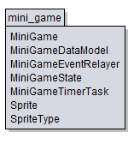
AudioManager Framework
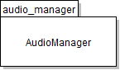
Ramble On Game Application
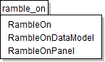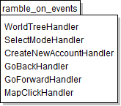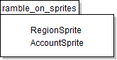

Figure 2.1: Design Packages Overview

2.2 Java API Usage

Both the framework and the mini-game application will be developed using the Java programming languages. As such, this design will make use of the classes specified in Figure 2.2.
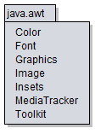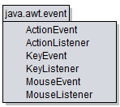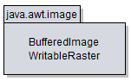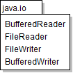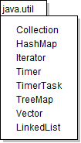
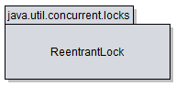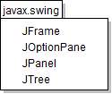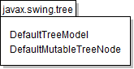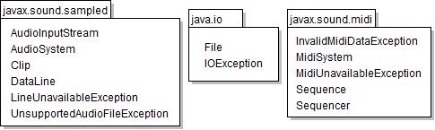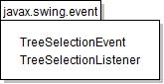

Figure 2.2: Java API Classes and Packages To Be Used

2.3 Java API Usage Descriptions

Tables 2.1-2.7 below summarize how each of these classes will be used.

Class/Interface | Use
Color | For setting the rendering colors for text and the progress bar
Font | For setting the fonts for rendered text
Graphics | For rendering text, images, and shapes to the canvas
Image | For storing image data
Insets | For changing component margins
MediaTracker | For ensuring synchronous image loading
Toolkit | For loading images

Table 2.1: Uses for classes in the Java API’s java.awt package

Class/Interface | Use
ActionEvent | For getting information about an action event like which button was pressed.
ActionListener | For responding to an action event, like a button press. We will provide our own custom implementation of this interface.
KeyEvent | For getting information about a key event, like which key was pressed.
KeyListener | For responding to a key event, like a key press. We will provide our own custom implementation of this interface.
MouseEvent | For getting information about a mouse event, like where was the mouse pressed?
MouseListener | For responding to a mouse event, like a mouse button press. We will provide our own custom implementation of this interface.

Table 2.2: Uses for classes in the Java API’s java.awt.event package

Class/Interface | Use
BufferedImage | For storing image data where pixel information can be accessed and changed.
WritableRaster | For changing pixel data in a BufferedImage. We’ll use this to add transparency to pixels loaded with the color key.

Table 2.3: Uses for classes in the Java API’s java.awt.image package

Class/Interface | Use
BufferedReader | For reading text files, we’ll use this for loading some game data at startup.
BufferedWriter | For writing text files, we’ll use this for save accounts
FileReader | For reading files.
FileWriter | For writing files.

Table 2.4: Uses for classes in the Java API’s java.io package

Class/Interface | Use
Collection | For storing groups of data, Values in a Map, i.e. TreeMap or HashMap are stored in Collections. We’ll need to iterate through Collections for rendering.
HashMap | For storing (name,value) key pairs, we’ll use it for storing our Images, accessible using their ID names.
Iterator | For iterating through a data structure during operations like rendering.
Timer | Will execute our custom task at fixed intervals.
TimerTask | Our custom task to be executed at a fixed framerate. We will extend this class and provide the task implementation in the run method.
TreeMap | For storing (name,value) key pairs, we’ll use it for storing SpriteTypes and GUI components, accessible using their ID names.
Vector | For storing data like the Strings for rendering debugging text.
LinkedList | For storing data like the Strings of region names.

Table 2.5: Uses for classes in the Java API’s java.io package

Class/Interface | Use
ReentrantLock | For ensuring only one thread has access to program data.

Table 2.6: Uses for classes in the Java API’s java.util.concurrent package

Class/Interface | Use
JFrame | Provides the window for our GUI.
JOptionPane | Provides a popup dialog for error feedback and account input.
JPanel | Provides a canvas for the game to be rendered onto.
JTree | Provides a tree for user to select a region

Table 2.7: Uses for classes in the Java API’s javax.swing package

Class/Interface | Use
DefaultMutualTreeNode | For representing a region in a tree.
DefaultTreeModel | For managing tree nodes

Table 2.8: Uses for classes in the Java API’s javax.swing.tree package

Class/Interface | Use
AudioInputStream | For getting sound file.
AudioSystem | For accessing sound resources.
Clip | For storing a sound.
DataLine | For getting the data of a sound.
LineUnavailableException | To indicate a line can’t be opened.
UnsupportedAudioFileException | To indicate the audio file is not supported.
Table 2.9: Uses for classes in the Java API’s java.sound.sampled package

Class/Interface | Use
File | To store a file on user’s computer.
IOException | To indicate input/output error.
Table 2.10: Uses for classes in the Java API’s java.io package

Class/Interface | Use
InvalidMidiDataException | To indicate an inappropriate MIDI data.
MidiSystem | To access MIDI system resources.
MidiUnavailableException | To indicate MIDI component is unavailable.
Sequence | To store the sound
Sequencer | To play sequence
Table 2.11: Uses for classes in the Java API’s java.sound.midi package

Class/Interface | Use
TreeSelectionEvent | For getting information about a tree selection event, like which region was selected.
TreeSelectionListener | For responding to a tree selection event, like a region select. We will provide our own custom implementation of this interface.

Table 2.12: Uses for classes in the Java API’s java.swing.event package

3 Class-Level Design Viewpoint

As mentioned, this design will encompass Ramble On game application, the Mini-Game, and Audio Manager Frameworks. The following UML Class Diagrams reflect this. Note that due to the complexity of the project, we present the class designs using a series of diagrams going from overview diagrams down to detailed ones.

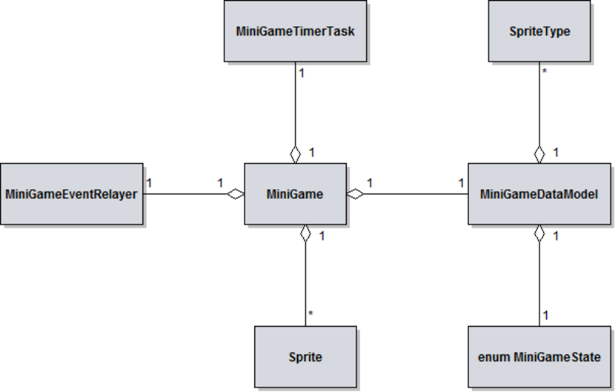

Figure 3.1: Mini-Game Framework Overview UML Class Diagram
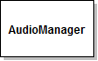
Figure 3.2: AudioManager Overview UML Class Diagram

Figure 3.2: AudioManager Overview UML Class Diagram
Figure 3.2: AudioManager Overview UML Class Diagra

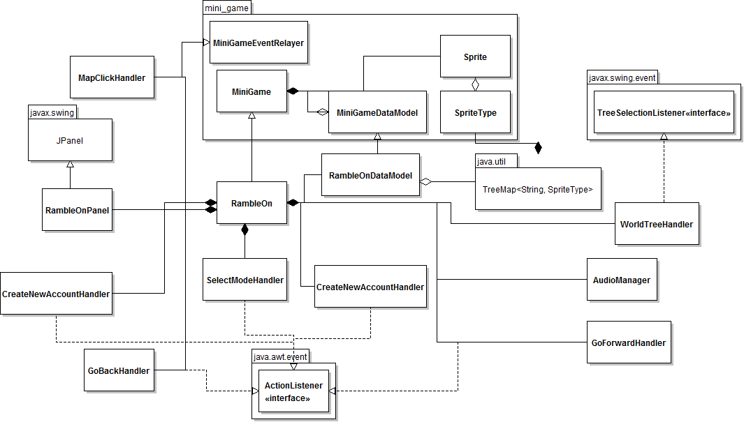
Figure 3.3: RambleOn Overview UML Class Diagram

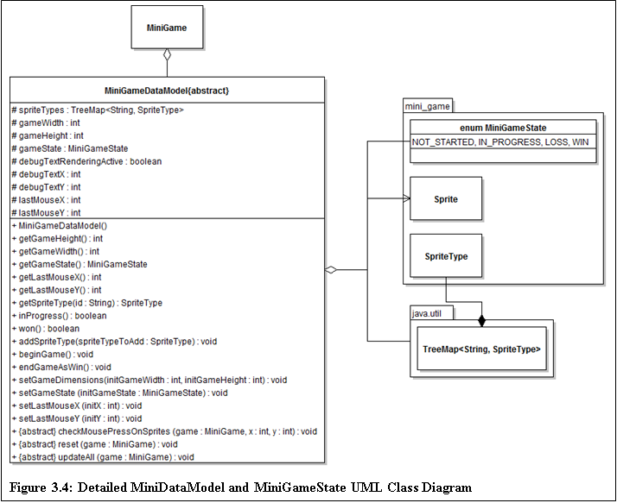

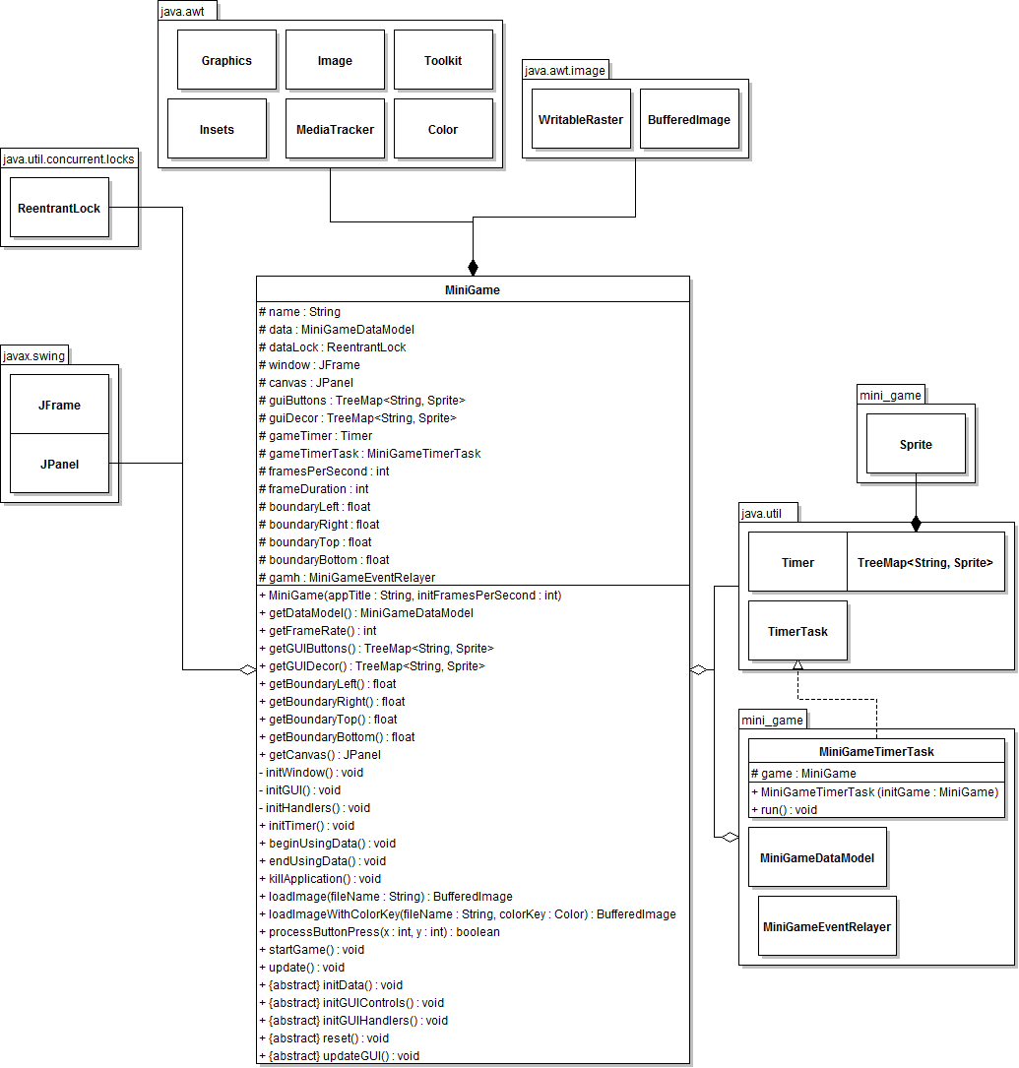
Figure 3.5: Detailed MiniGame and MiniGameTimerTask UML Class Diagram

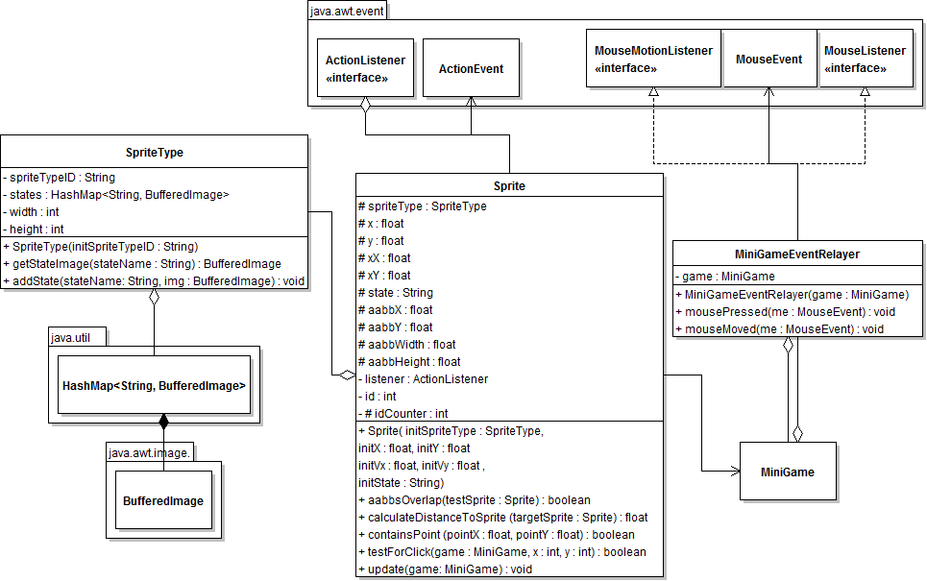
Figure 3.6: Detailed Sprite, Sprite, and MiniGameEventRelayer UML Class Diagram

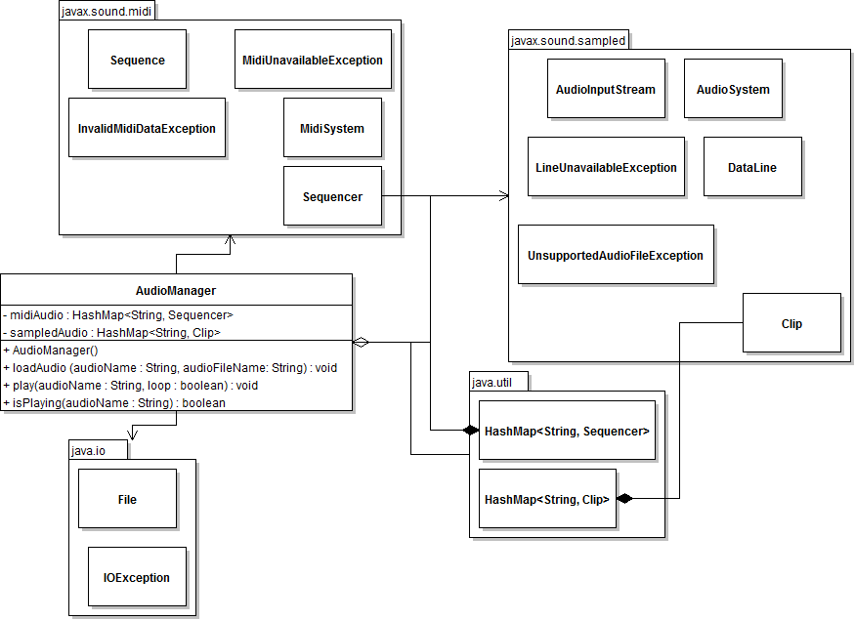
Figure 3.7: Detailed AudioManager UML Class Diagram

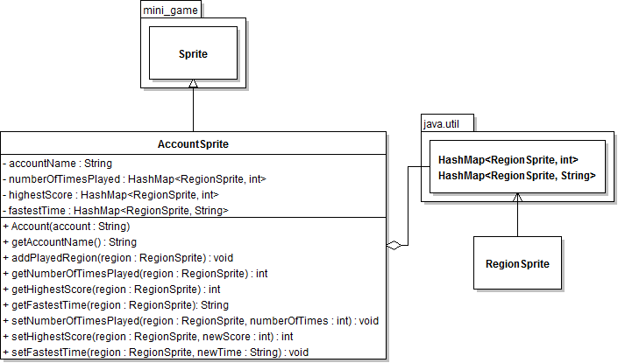
Figure 3.8: Detailed AccountSprite UML Class Diagram

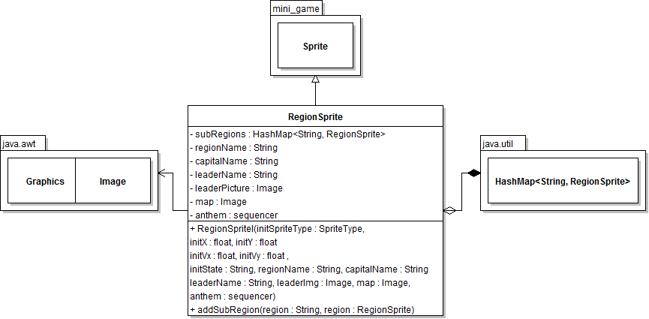
Figure 3.9: Detailed RegionSprite UML Class Diagram

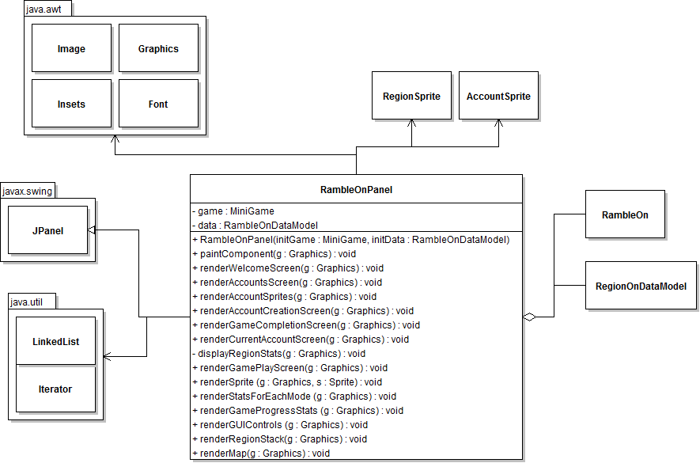
Figure 3.10: Detailed RambleOnPanel UML Class Diagram

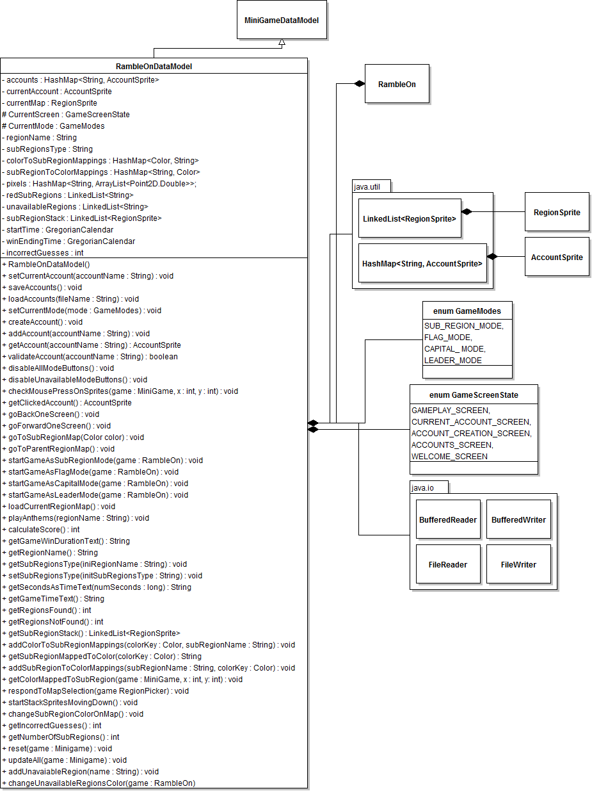
Figure 3.11: Detailed RambleOnDataModel UML Class Diagram

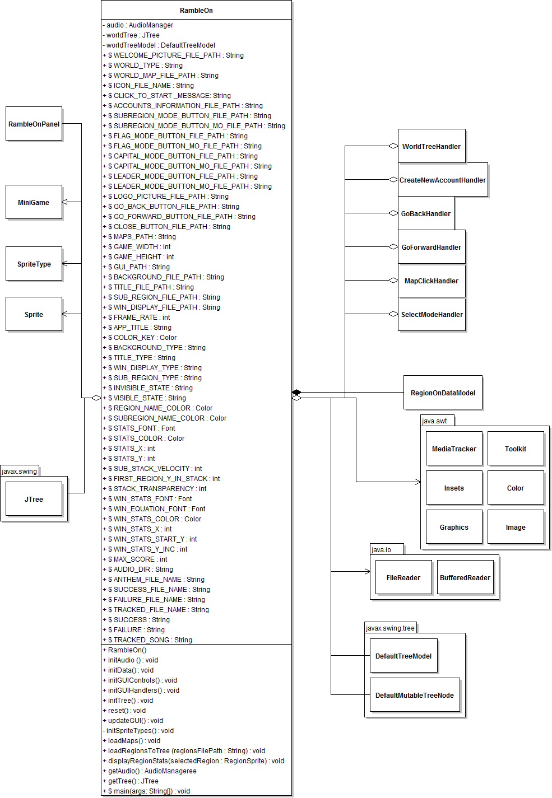
Figure 3.12: Detailed RambleOn UML Class Diagrams

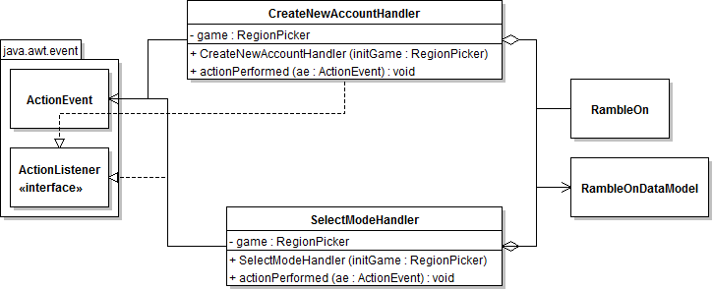
Figure 3.13: Detailed SelectModeHandler and CreateNewAccountHandler UML Class Diagrams

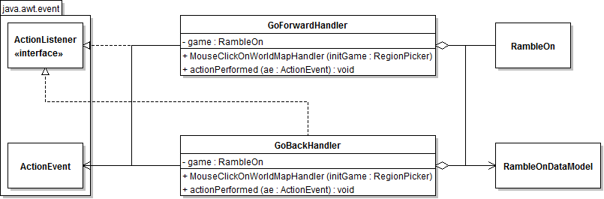

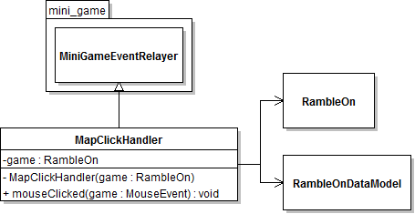
Figure 3.14: Detailed GoForwardHandler, GoBackHandler, and MapClickHandler UML Class Diagrams

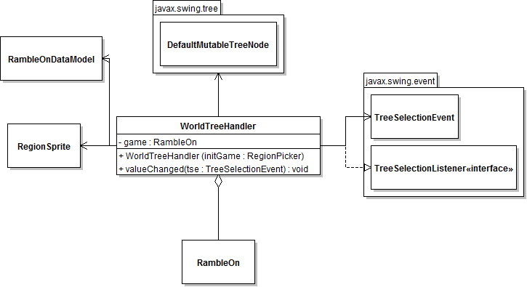
Figure 3.15: Detailed WorldTreeHandler UML Class Diagrams

4 Method-Level Design Viewpoint

Now that the general architecture of the classes has been determined, it is time to specify how data will flow through the system. The following UML Sequence Diagrams describe the methods called within the code to be developed in order to provide the appropriate event responses.
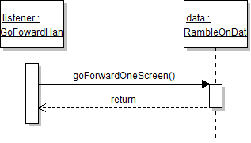
Figure 4.1: GoForwardHandler UML Sequence Diagrams

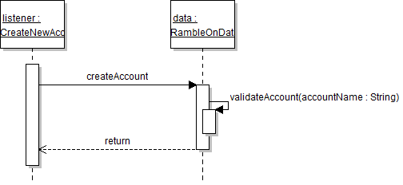
Figure 4.2: CreateNewAccountHandler UML Sequence Diagrams

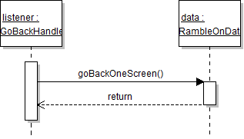
Figure 4.3: GoBackHandler UML Sequence Diagrams

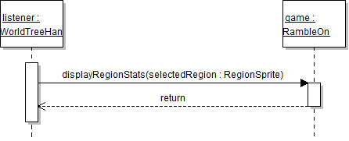
Figure 4.5: WorldTreeHandler UML Sequence Diagrams

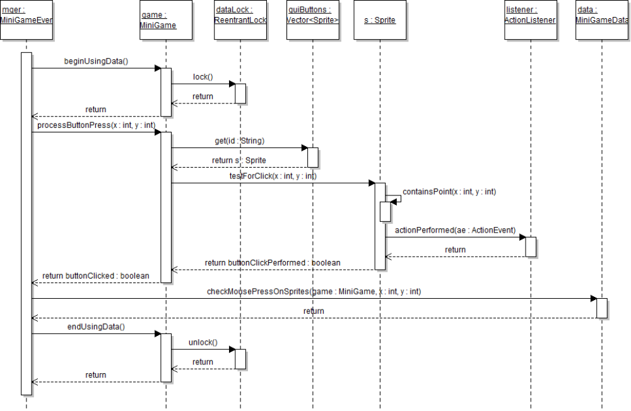

Figure 4.6: Mouse Click on Canvas UML Sequence Diagrams

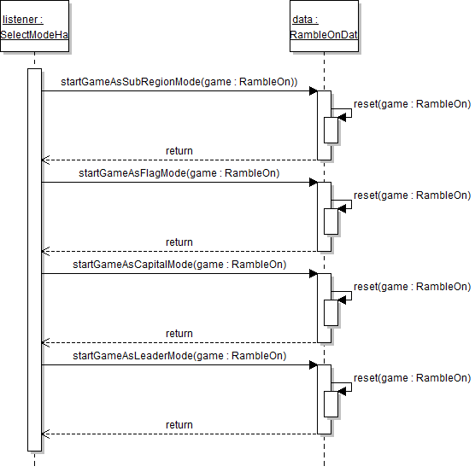
Figure 4.7: SelectModeHandler UML Sequence Diagrams

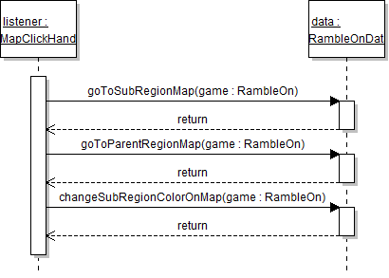
Figure 4.8: MapClickHandler UML Sequence Diagrams

5. File Structure and Formats

Note that the Mini Game and Audio Manager Frameworks will be provided inside MiniGameFramework.jar and AudioManager.jar, a Java ARchive file that will encapsulate the entire framework. This should be imported into the necessary project for the Ramble application and will be included in the deployment of a single, executable JAR file titled RambleOn.jar. Note that all necessary data and art files must accompany this program. Figure 5.1 specifies the necessary file structure the launched application should use. All data should go into data directory.

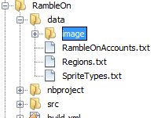

Figure 5.1: RambleOn File Structure

The Regions.txt, RambleOnAccount.txt and SpriteTypes.txt provide the data for all regionsprites and accountsprites. The files are raw text files that can be used to describe accountsprites and region sprites, each with their own information as follows:

NumSpriteTypes
SpriteType_1
…
SpriteType_M

NumAccounts
ACCOUNT_1_REGIONNAME_1|HIGHESTSCORE
ACCOUNT_1_REGIONNAME_1|FASTESTTIME
ACCOUNT_1_REGIONNAME_1|NUMBEROFREGIONSPLAYED
ACCOUNT_1_REGIONNAME_2|HIGHESTSCORE
ACCOUNT_1_REGIONNAME_2|FASTESTTIME
ACCOUNT_1_REGIONNAME_2|NUMBEROFREGIONSPLAYED
…
ACCOUNT_N_REGIONNAME_N|HIGHESTSCORE
ACCOUNT_N_REGIONNAME_N|FASTESTTIME
ACCOUNT_N_REGIONNAME_N|NUMBEROFREGIONSPLAYED

NumCountries

STANDARD_ANTHEM_FILE_PATH
BACKGROUND_MUSIC_PATH
REGIONNAME_1|LEADER_NAME_1|LEADER_IMAGE_FILE_1|CAPITAL_NAME_1|MAP_FILE_PATH_1|ANTHEM_FILE_PATH_1
REGIONNAME_2|LEADER_NAME_2|LEADER_IMAGE_FILE_2|CAPITAL_NAME_2|MAP_FILE_PATH_2|ANTHEM_FILE_PATH_2
…
REGIONNAME_N|LEADER_NAME_N|LEADER_IMAGE_FILE_N|CAPITAL_NAME_N|MAP_FILE_PATH_N|ANTHEM_FILE_PATH_N

We can describe these values as follows:

NumSpriteTypes: an integer that lists the total number of Sprite Types to be loaded. Note that this value must correspond to the number of Sprite Types that will be described by the file using the proper format.

SpriteType_X – the textual name of a type of sprite.

NumAccounts– an integer that lists the total number of accounts

ACCOUNT – The name of number N account.

REGIONNAME_N–The name of number N region

HIGHESTSCORE – the highest score that this user achieve for a region.

FASTESTTIME – the fastest time to complete the region.

NUMBEROFREGIONSPLAYED – the number of times that user play this region

NumCountries : the number of countries in this world map

STANDARD_ANTHEM_FILE_PATH : the path of standard anthem.

BACKGROUND_MUSIC_PATH: the path of background music.

REGIONNAME_N : the name of number N country.

LEADER_NAME_N: the leader’s name for number N region.

LEADER_IMAGE_FILE_N : the image of number N region’s leader.

CAPITAL_NAME_N : the name of number N regions’ capital.

MAP_FILE_PATH_N : the path of number N region map.

ANTHEM_FILE_PATH_N : the path of number N region anthem.

6. Supporting Information

Note that this document should serve as a reference for those implementing the code, so we’ll provide a table of contents to help quickly find important sections.

  - Table of contents

- Introduction 2
  - Purpose 2
  - Scope 2
  - Definitions, acronyms, and abbreviations 2
  - References 3
  - Overview 3
- Package-Level Design Viewpoint 4
1. RambleOn, Mini Game, and AudioManager overview 4
2. Java API Usage 5
3. Java API Usage Descriptions 5
- Class-Level Design Viewpoint 9
- Method-Level Design Viewpoint 20
- File Structure and Formats 23
- Supporting Information 25
  - Table of contents 25
  - Appendixes 25

  - Appendixes

N/A

